
Exhibition Trailer Hire - Preferred Supplier to PAWRS
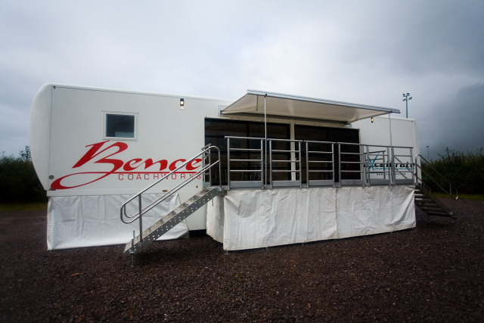

Contact Name: ……………………………………………………………………………………………………………………..
Company Name: …………………………………………………………………………………………………………………..
Address: ……………………………………………………………………………………………………………………………….
………………………………………………………………………… Postcode ………………………………………………….
Email Address: ……………………………………………………………………………………………………………………….
Tel No: ……………………………………………………………………………………………………………………………………

Please supply me with a quote - I am interested in trailer sizes 4.2m/5.5/6m/7m/9m/13m
our plot size is ………………………………………………………………………………………………………………………..

Please return this enquiry form to: Jackie.ogborne@whbence.co.uk or call on 01454 310909
For more details on our Trailers and Services please visit our website: www.whbence.co.uk

W H Bence Exhibitions, Great Western Business Park, Armstrong Way, Yate, Bristol BS37 5NG 01454 310909

